Guide 3. APT Project Final Report
Phase 2 · NexusWST / WeStorage · Progress during Sprint 1 (October 2026 snapshot)
October 2026 progress snapshot: Sprint 0 is complete and Sprint 1 is approaching closure. The reported outcomes concern design, technical preparation, and planning; they are not evidence of a fully deployed product.
Project name | NexusWST — We Manager modernization for WeStorage
Professional areas | Requirements engineering, databases, back-end/full-stack development, architecture and quality, agile project management.
Graduate competencies | C1: software design and quality; C2: information solutions; C3: requirements engineering; C4: project management; C5: lifecycle design, security and sustainability.
Team | Jean Carlos Diaz Perez and Cristopher Alberto Lobos Martínez.

1. Relevance of the APT project
WeStorage provides logistics services and uses We Manager to manage orders from sales channels and coordinate with couriers and INVAS, its external warehouse management system. The existing solution is tightly coupled, which complicates maintenance and evolution. NexusWST proposes a modular technical foundation to improve order processing, traceability, and data control without replacing INVAS. It applies requirements engineering, architecture, databases, and software development to a real business need.

2. Objectives
General objective. Progressively design and implement the NexusWST foundation for end-to-end order management, integrating core supporting modules, external systems, and quality controls agreed with WeStorage.
Specific objectives:
- Define order requirements, processes, and business rules.
- Establish the 4+1 architecture, data design, and INVAS integration boundaries.
- Incrementally implement authentication, Clients, Products, and priority Orders features.
- Prepare a reproducible environment and apply quality, validation, and testing criteria.
- Track risks and evidence through Scrum, Jira, and client validation.

3. Methodology
The team applied Scrum with Jira tracking, reviews with the client, and internal retrospectives. Sprint 0 closed the initial business analysis and design; Sprint 1 delivered most technical artifacts and the Docker skeleton. User stories were specified with acceptance criteria and broken down into estimated tasks with clear ownership. Sprint 2 (Oct 21–Nov 3) has a documented DoR/DoD and an incremental development goal, with workload and dependency controls. This approach supports inspecting progress and adjusting the backlog without claiming that unbuilt features are complete.

4. Development, challenges, and adjustments
Activities and results. ERS, DAS, and project charter v1.0 were prepared, together with As-Is and To-Be BPMN diagrams, preliminary use cases, 4+1 architectural views, state, component, deployment and sequence diagrams, a permission matrix, and a skeleton using Docker, Traefik, Redis, and PostgreSQL. The technical plan includes 18 version 1.0 user stories and 129 estimated tasks, with two PERT analyses to identify dependencies. The Jira screenshot marks 10 of 12 Sprint 1 items completed. Mockups v0.5 remain in progress, while validation of the pending-decisions register v0.9 is outstanding.
Decisions and changes. During the client review, Ismael supported the general architecture, Redis, and queues for coordinating exchanges with INVAS. Profiles must be configurable for each client company, and NexusWST will not implement a separate Picker role because that operation remains in INVAS. Several courier, status, and data-flow details still require confirmation; they are tracked in the decisions register rather than represented as closed rules.
Next stage. Sprint 2 is planned to implement the frontend foundation, login, users and permissions, client companies, product catalog, and initial order capabilities: intake, validation, and history listing. H-06 (orders from external channels) is a reserve item should capacity become constrained. As of this report, there is no evidence of fully integrated APIs, complete live validation against INVAS, executed acceptance tests, or production deployment.

5. Evidence
Attached evidence supports documentation, tracking, and planning—not a production release. Additional supporting files include ERS/DAS and project charter v1.0, use cases, stories v1.0, permissions matrix, PERT, Jira board, and review/retrospective records. The definitive project report will need code, test results, and integration evidence when available.

6. Professional interests and career outlook
The project reinforces Jean Carlos’s interests in back-end/full-stack development, architecture, and enterprise software design; his work on documentation, diagrams, requirements, and planning supports an end-to-end understanding of the software lifecycle. Cristopher has focused on process modeling, client communication, and infrastructure. As a team, they intend to deepen their experience in implementation, integrations, quality, and cloud infrastructure through continued learning.

Project supporting records
Phase 1 Guide 1; Sprint Review and Sprint Retrospective; Sprint Planning 2; User Stories v1.0; User Story Tasks v1.0; pending-decisions register v0.9; Jira boards; PERT diagrams.

Appendix A. Jira status
Sprint 1: 10 items completed, mockups in progress, and pending-decisions validation outstanding.
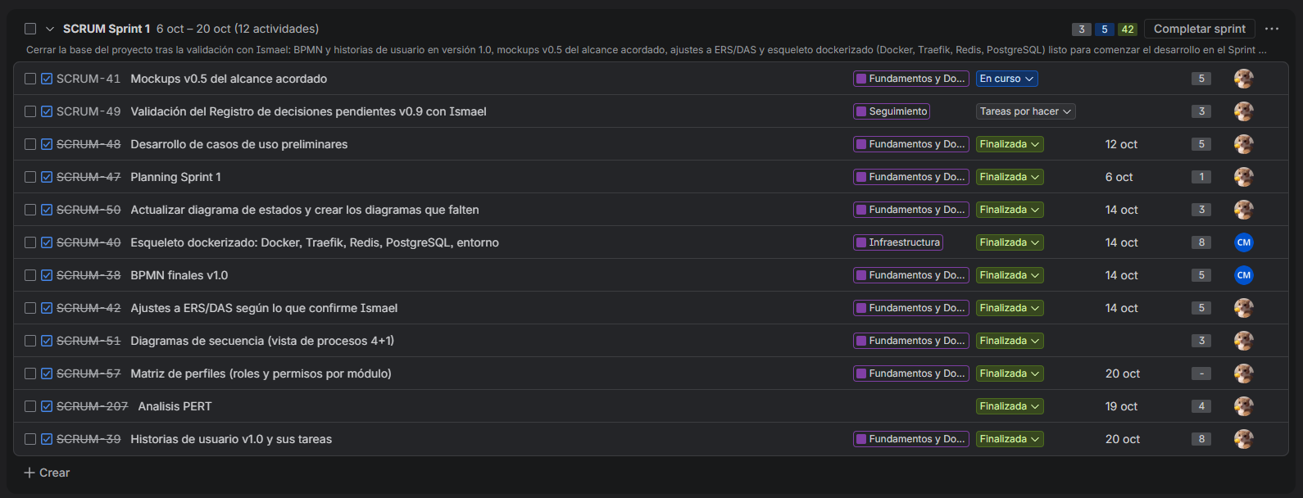

Anexo A.2 Tracking in Jira
Sprint 2: Planification to the next Sprint
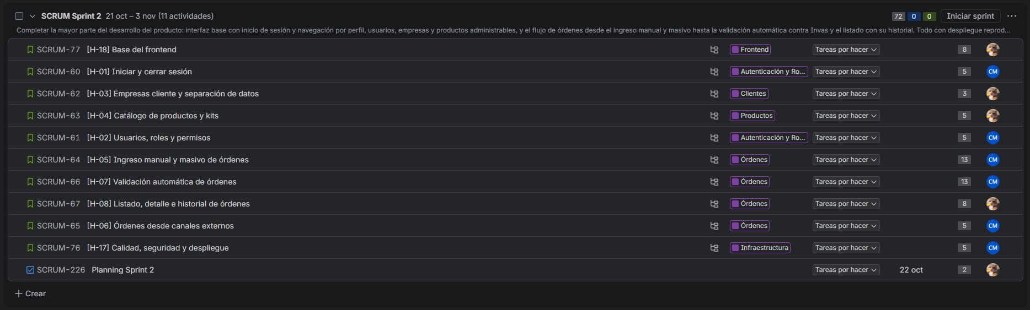

Appendix B.1 PERT planning (Sprint 0)
Evidence of analysis and dependency planning.
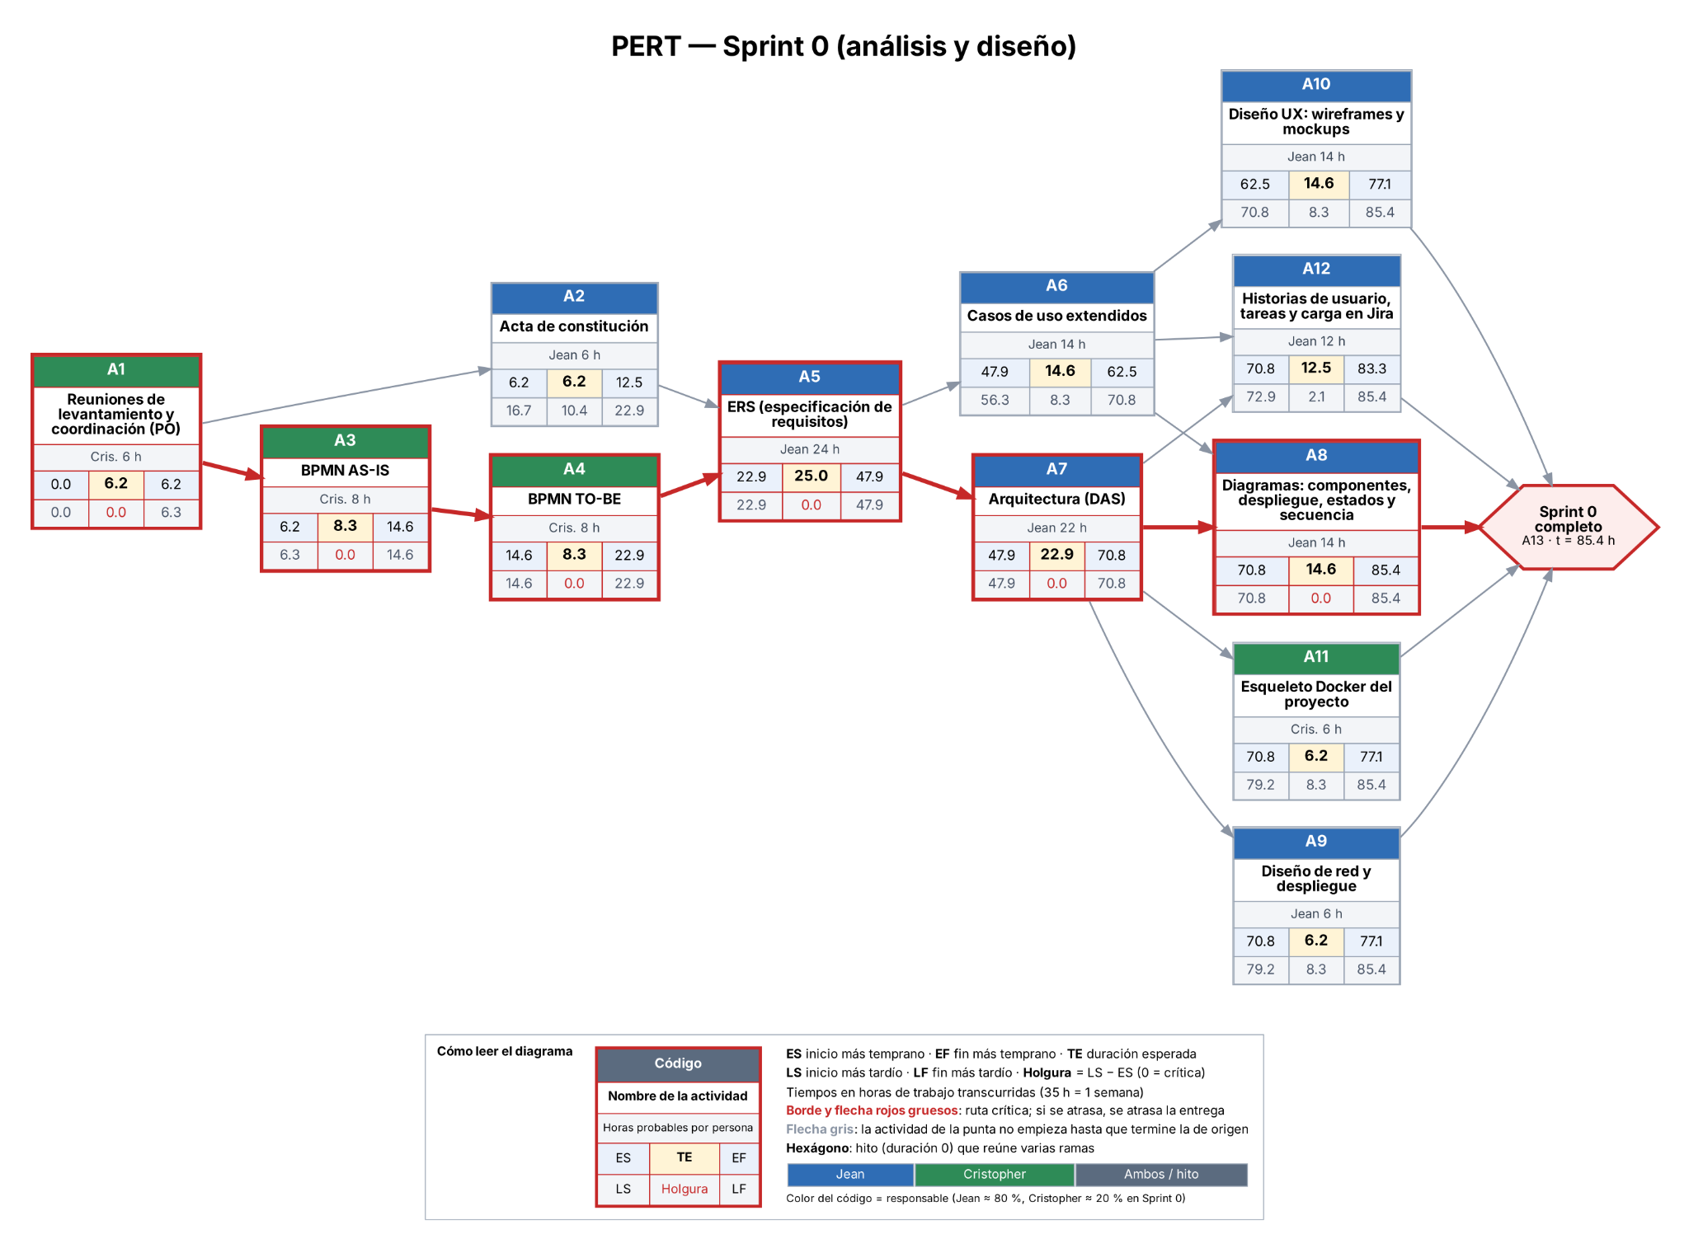

Appendix B.2 PERT planning (Sprint 1,2,3)
Evidence of analysis and dependency planning.
